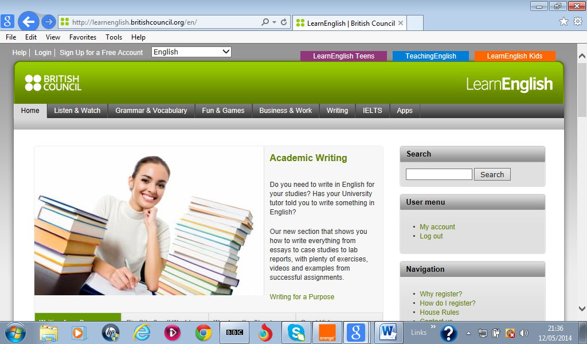
Teaching in Action! Webquest- win a laptop!

Full name ………………………………………… Tel Number……………………….
Email address……………………………………………………………..
To enter this Teaching in Action! webquest competition, complete your personal details above, then visit the LearnEnglish website http://learnenglish.britishcouncil.org/en/ and find the answers to the 5 questions below. Write your answer for each question in the spaces …………. below. Save this document and send it to English4future@tn.britishcouncil.org by Wednesday 3rd June 2015.

1.Click on Listen & Watch section   | Go to the Talk About section, then listen to Beating Stress.  What does the word S-T-R-E-S-S mean?  …………………………………………………………………………
2. Click on the Fun & Games section.   | Go to the practice activity Verb Machine.  How many colours do you have to change the verb form?  ………….…………………………………………………………………
3. Click on Business & Work section.   | Go to the ‘You’re Hired’ videos. Watch episode 10.  How many people will be under Sarah in the new office?  …………………………………………………………………………….
4. Click on Listen & Watch section   | Go to ‘Magazines’ section and find the article about Physical education.  Why was the final part of climbing the mountain more difficult??  ……………………………………………………………………………
5.Click on the Apps section.  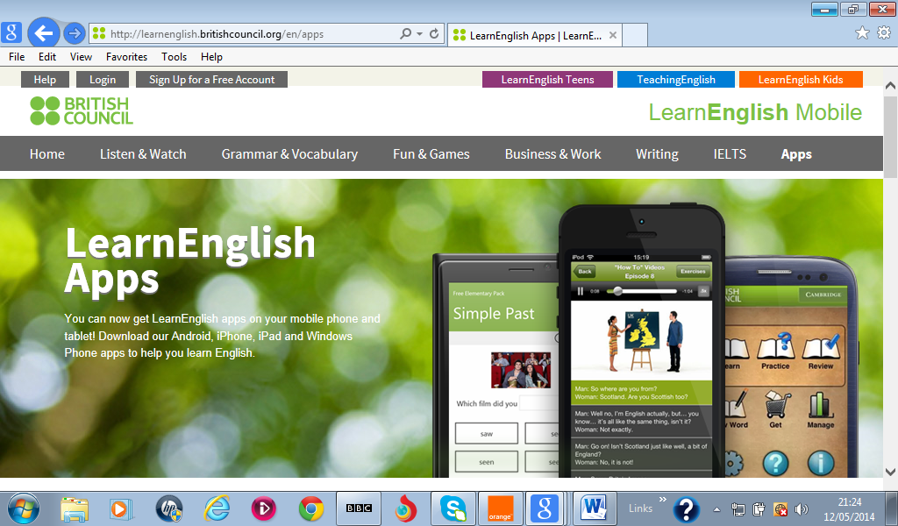 | Which Learning Tools Apps improves your grammar skills?  ………………………………………………………………………….
By entering this competition and writing my name above, I confirm that I have read and agree to the conditions in the British Council webquest TiA! May 2015 - Competition guidelines document.
Good luck!

